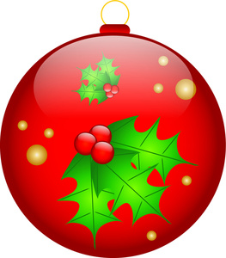
City of Vincennes
2nd Annual Christmas in the Park
Drive Through
Friday, December 3, 2021
& Saturday, December 4, 2021
6:00 p.m. – 9:00 p.m.

RULES & INSTRUCTIONS

- All entries must be decorated and lit using your own power source.
- The committee reserves the right to reject any entry forms.
- The City of Vincennes will host Santa for the event. No other Santa’s will be allowed.
-------------------------------------------------------------------------------------------------------

ENTRIES MUST BE RECEIVED BY Monday, November 29, 2021. NO LATE ENTRIES!

*** must be filled out completely ***

Organization ____________________________________________________________________

Address ________________________________________________________________________

Contact Person _______________________________ Phone Number_______________________

Contact Person’s Email Address_____________________________________________________

WILL YOU PARTICIPATE:
Friday Evening: ______ Saturday Evening: ______ Both Evenings: ______

CATEGORY (choose one)
___Business/Corporation ___ Band ___Non-Profit/Church
___Service Organization _____ Dance/Gymnastics
___Specialty Unit; describe ___________________________

Display Dimensions: ______L ______W ______H

Locations will be sent via e-mail once finalized.
*Map will also be posted on www.vincennes.org & Vincennes Mayor’s Office Facebook page

Entries may be returned by:
Email: chacker@vincennes.in.gov
Mail: 201 Vigo Street, Vincennes, IN 47591

