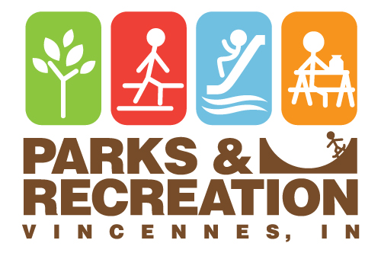
201 Vigo Street - Vincennes IN 47591 – 812-882-1140
Office Hours: Monday thru Friday 8:00 a.m. – 4:00 p.m. (after hours call 812-881-1631)

___ Enclosed ___ Enclosed & Porch ___ Porch Only ___ Four Lakes
$45.00 + $3.15 tax $65.00 + $4.55 tax $30.00 + $2.10 tax $30.00 + $2.10 tax

Shelter Requested:
___ Band Shell ___ Open ___ Open North ___ Open South ___ Chicago Park
$30.00 + $2.10 tax $60.00 + $4.20 tax $35.00 + $2.45 tax $35.00 +$ 2.45 tax $30.00 +$ 2.10 tax

Day & Date Requested ________________________________________________________________
Type of Activity _______________________________________________ # in Attendance ________
Arrival Time __________________ Departure __________________ (available from 9:00 a.m. to 10:00 p.m.)
Individual legally & financially responsible ________________________________________________
Address _________________________________ City _________________ State ______ Zip _______
Phone ___________________________________
STATEMENT OF LIABILTY AND RESPONSIBILITY

This facility shall not be used for commercial purposes or for private gain. No person shall sell, offer to sell, or barter any goods, wares
or merchandise of any kind within any public park, playground or other facility without first having obtained written consent from the Vincennes Park & Recreation Board. Although the Vincennes Park & Recreation Dept. exercises every reasonable precaution, it assumes no responsibility or liability for any programs presented or for any accidents, damages or injuries which might occur while rented by an organization or individual. Renters of Department facilities will be responsible for the reasonable protection and care of public property.

- NO ALCHOLIC BEVERAGES are permitted on park property.

- Pets are permitted in the shelter houses but must be on a leash. Please dispose of pet waste properly.

- Fires are only permitted in the enclosed/open shelter fireplaces and must be properly extinguished.

- Portable grills are permitted outside of the shelters and must be located at least 25 ft. from any structure.

- Parking will only be permitted in designated areas.

- All trash must be bagged and placed in receptacles provided.

- Do not attach decorations to walls by any means.

- Park hours are 6:00 a.m. - 11:00 p.m. daily. Shelter rentals are available 9:00 a.m. to 10:00 p.m.

- Any group or individual that abuses a shelter or violates rules and regulations will not be issued future reservations, and
any charges for damage may be assessed.

- Noise is to be kept at a reasonable level.

- Cancellation Policy - To be eligible for a refund, reservation must be cancelled at least 1 month prior to scheduled use.

At your event please remember to social distance and follow other CDC guidelines regarding sanitizing & masks.

I agree that all the information listed above is true & accurate & that I agree to the terms & conditions listed within this document.

___________________________________ _____________ _____________ _____________
Applicant Signature Date Amount Paid Receipt #

